Representing What Student and Faculty Partners Have Explored

In Chapter 6 of Student-Faculty Pedagogical Partnerships in the Classroom and Curriculum: A How-To Guide for Faculty, Students, and Academic Developers in Higher Education, we pose the question: How can student partners capture all the work they and their faculty partners have done over the course of their partnership? The two primary ways in which student partners in the SaLT program represent and acknowledge what they and their faculty partners have explored is through annotated lists and thank-you letters.

Annotated Lists

One of the final responsibilities of student partners in the SaLT program is to draw on all their notes to create annotated lists or other representations of what they hope their faculty partner will be able to celebrate and also to keep working on in future. To create such an annotated list, student partners read back through all of their observation notes, notes from weekly meetings, and any other resources. They can also ask their faculty partners (1) to revisit and reiterate their original goals from beginning of semester and (2) to identify goals they have going forward. These questions can help student partners shape their annotated lists.
Some student partners present their annotated lists this way:

Pedagogical Strategy: Small Group Discussions

Description: You often have the class break into smaller groups to discuss. Sometimes, you have the groups already assigned while other times you have students count off to form these small groups. You travel between the groups to hear from and participate in their discussions

Benefits: Some students feel more comfortable in smaller settings. Small group discussions give a larger variety of students the chance to participate. Small group discussions also allow for students to get to know each other better, and see how other students investigate texts

Potential Drawbacks: Sometimes, students wouldn’t really talk to one another or try and answer the question, but would instead wait until you had arrived at their group and expect you to answer the question for them

For Next Time: It might be helpful to have students always work in the same groups and to have these groups be connected to student writing as well. It also might work if you only sat with one group (as a full group member) rather than floating between the groups and therefore giving some students the chance to simply ‘wait’ until you arrived at their group and gave them the ‘answers’

Description: You allowed for time to work pairs/discussion groups, whether to answer a question, discuss a difficult research design, improve a study design, or brainstorm policy applications

Benefits: This approach helped fuel discussion. Students had time to think about and make sense of their own observations before sharing with the class, which gave them support. Also, they are teaching and learning from their peers as they exchange ideas. When you would shift attention back to the full class, students who may not have participated otherwise are more prone to want to contribute what they have discussed

For Next Time: There could be an opportunity in a future version of this course for students’ evaluation [grade] to reflect these efforts. Although you made it clear in the syllabus from the beginning that their evaluation [grade] would not be based on class participation, students were energized and engaged by these activities, and it would be great to have some aspect of this critical thinking as a portion of their grade

Other student partners use a different format. The following list of practices, strategies, and approaches is an example of one that Melanie created for one of her faculty partners when she was a student partner in the SaLT program. It included practices that she and her faculty partner discussed and that she used in her class. Melanie included with each practice a short annotation describing each item and saying affirming how her faculty partner used them effectively to accomplish her goal of creating a dynamic and inclusive learning environment. Selections from this list are included in Chapter 6.

Feedback & Assessment
- One-on-one meetings with each student at the beginning of the course
  - This is a really great way of overcoming the initial hurdle of office hours while also getting to know students and their expectations for the course.
- Student self-assessment
  - Exit slips: At the end of class, asking students to reflect on something they learned and something they found confusing about the class that day. These questions can also be adjusted depending on what you want to find out about the students’ understanding or experience.
- Student feedback on presentations
  - When students are facilitating or presenting, you can consider asking the other students to make some notes in response to questions you prepare. This can both give you and the presenter(s) feedback on how accessible their presentation was, and also provide an opportunity for the audience to engage more with the material

Material
- Bringing in examples
  - It’s so helpful when professors can bring in examples from the relevant literature or (especially) from their own research. This allows students to make connections beyond the course material and to think about experimental design.
- Personal experience
  - Making space for personal experiences to be brought into discussion is a way of making theoretical or experimental information more concrete. As we’ve discussed and as the students in this course indicated on their midsemester feedback, it’s important to ensure that sharing personal experiences doesn’t distract from the literature or conceptual material that needs to be covered and discussed.

Facilitation
- Giving multiple opportunities for students to ask questions
  - This is something that I have really appreciated seeing you do this semester. Providing frequent opportunities for students to ask questions gives them time to think and normalizes the act of asking questions by making space for them.
- Organizing the discussion questions by category
  - This is a small thing, but I think it does a lot to contribute to the structure of discussion. It’s helpful to be able to connect discussion questions to one another, and having them visually close to one another makes that easier.
- Turning questions back to the entire room
  - I think that your habit of redirecting questions posed by students back to the rest of the class is a useful teaching tool. It allows students to take ownership of their understanding of the material by providing information to one another, and also democratizes the classroom a little bit by acknowledging that students are capable of parsing and explaining course material.

Pedagogical Transparency
- Assignments as skill-building
  - You’ve talked explicitly to students this semester about how the assignments for the course build on each other and provide opportunities for students to develop their skills. I think this is a really wonderful and helpful way for you to structure the assignments, and I think talking about it with the class allows them to be more critically aware of how they are applying different skills to each assignment. They can also take away a greater sense of what they have learned in the course.
- Giving an agenda
  - Giving an agenda for the class meeting, either orally or in writing on a slide or on the blackboard, is an important way of roadmapping learning for students. When they have a sense of the plan for the class meeting the discussion can be more focused.
- Your role during small group work
  - I appreciated that you articulated to students what you would be doing while they discussed in pairs or small groups. I think it was meaningful that you let them know that you would be standing by taking notes to bring back to the large group so that they weren’t worrying about what you were doing. By being transparent in this way, small group discussions are able to continue as you move around the classroom.

Activities
An overarching theme throughout the semester has been how dynamic your classes are, and what a wide variety of activities you use to keep things moving and feeling fresh. These are some examples of things that I thought were particularly successful and that might translate well to other courses also.
Something we talked about in our meetings has been the idea of “high challenge, low risk” tasks as good learning opportunities. We identified some ways to create “high challenge, low risk” moments in the class, such as asking students to jot down their reactions or analyses in response to a prompt. Some of the following activities are also examples of creating “high challenge, low risk” situations in the classroom.
- Filling out a measure
  - You had the students respond to a measure that had been used for an actual study. They then calculated their individual means and returned them to you anonymously so that you could calculate the overall class mean and discuss the results. This was a very interactive activity and also provided an example of how a study might be conducted, and what analyses might be drawn from the results.
- Silent discussion
  - One of the book project groups distributed quotations from their book around the room and asked students to respond to their quotes and to others’ responses using post-its. I liked that this was a way for students who are less talkative to contribute meaningfully, and for multiple people to respond to the same comment. I’ve also seen this done successfully on blackboards (if there’s enough space and chalk) or on large pieces of paper on the walls throughout the classroom. I think it’s a particularly effective way to talk about a reading or a book, especially if the students themselves choose the quotations that will be discussed.
- Human barometer
  - This was an activity conducted by some students when they facilitated class. Sometimes having everyone get up and move around can enliven the discussion, and it’s also an interesting way to merge personal experience/opinion with connections to theory or data.
- Guessing the results of a study
  - This was an activity that you conducted a few times: students read a description of the research questions and methodology of a study, and you asked them to hypothesize about the results before they saw the actual outcomes. This builds skills in hypothesis generation, and it’s very engaging. You asked the students to discuss their guesses with a partner; another approach could be asking them to write down their predictions, either before discussing with a partner or just as a “low risk” opportunity.
- Mind maps
  - Both you and one of the book project groups used this activity very successfully. One or more concepts (or quotations, or…) are put up on the board and the students can make connections or write up their impressions. Similar to silent discussion, it allows everyone to participate and to build a collaborative understanding of the material.

Another student partner in the SaLT program, Crystal Des-Ogugua, developed a different approach. As she wrote to her faculty partner: “This is a compilation of observed efforts you took to set up a positively functioning classroom environment. I have condensed my notes/observations into a chart that shows how you impacted classroom discussions, student comprehension of materials/content, and students responsiveness in class.” Crystal developed a key:

KEY

Teacher-Student: Efforts made by the teacher that directly impact the student

Student-Student: Efforts made by the teacher that encourage and promote student-to-student interaction and learning

Student-Classroom: Efforts made by the teacher to promote student participation and interaction with the entire classroom environment

Teacher-Classroom: Efforts made by the teacher to engage and improve the entire classroom environment

*(Potential Section) Student-Self: Efforts made by the teacher to facilitate and engage student self-development

The chart looked like this:
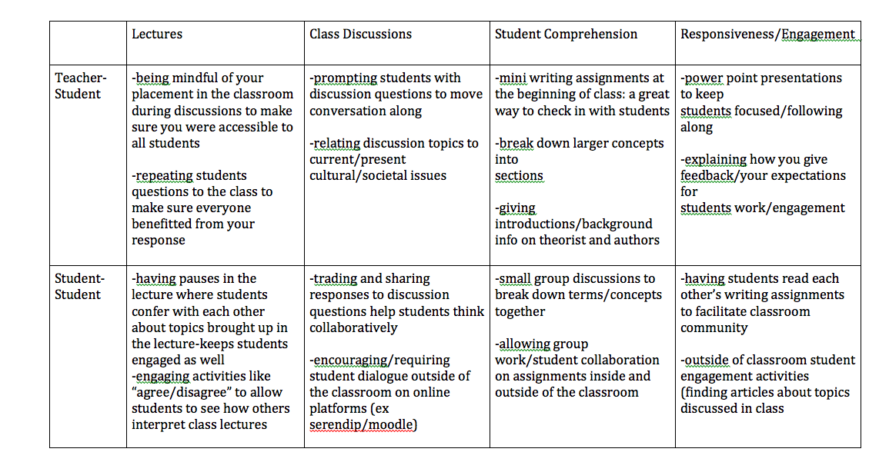
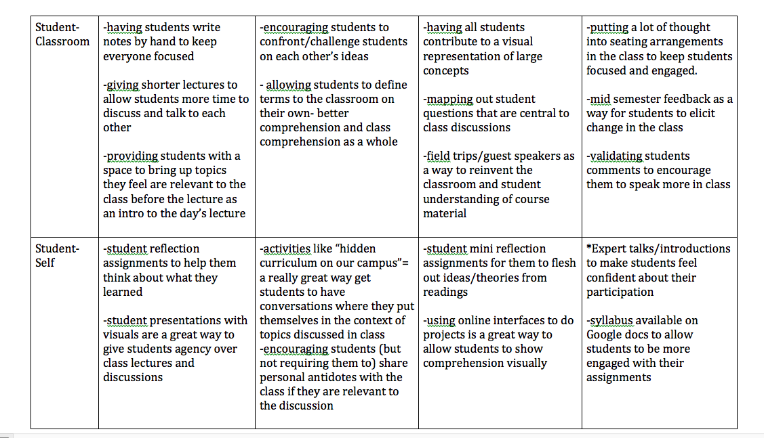

Writing Thank-You Letters

In preparing to write their thank-you letters, it is helpful for student partners to look over the notes they have gathered throughout the semester to help themselves recognize and draw out common themes. Reviewing their notes is a great way to refresh their minds regarding moments that may have been memorable, sparked a shift in the partnership, or encouraged the student partner’s own growth.
Next, it is important for the student partner to decide which themes they are most comfortable sharing as a representation of the general takeaways from the partnership. After spending so much time with a faculty partner, it might be easy to look past areas of growth and only point out what needs improvement. It can be much harder to affirm and recognize all the work that the student partner has put into supporting the faculty partner’s pedagogy, regardless of whether the partnership was challenging or not.
One of the best ways to organize themes and appreciations is by having a few sentences that state the student partner’s general understanding of where both partners started and how far they both have come (accomplishments come through acknowledging the incremental change and the quality of the interactions, whether in relation to the student partner, the course, the faculty partner’s practice, etc.). If the partnership was challenging, frame those challenges as learning opportunities and moments of growth that encouraged thinking and the way one can share perspective. Student partners can utilize the themes they have identified as contextual evidence for items to remember and look forward to.
Student partners might choose to mention, and express gratitude for, the ways that the partnership has helped them grow alongside their faculty partner. Through partnership, student partners develop skills in a range of areas, from deep listening and giving constructive feedback to greater empathy and self-confidence. Naming these areas of growth and affirming them as outcomes of the partnership is a useful opportunity for reflection for student partners and makes the mutual benefits of partnership clear to faculty partners. For students whose partnerships may have been challenging, articulating the areas of their own growth can serve as a reclamation of the time and energy they have dedicated to the partnership process.
The purpose of a thank-you letter is to specifically thank the faculty partner for the ways in which their openness, availability, and willingness to utilize the program to reflect on their pedagogy and even outlook on situations affected the student partner’s own understandings of teaching, learning, and themselves as pedagogical partners. It is to remind both partners how much they have grown and how much of an impact their work together has had. It is always a great feeling knowing that the partnership has concluded by recognizing moments to remember and ways to move forward.
While in the SaLT program it is primarily student partners who write these thank-you letters as part of their reflection on and documentation of the partnership work, many faculty partners also write thank-you letters, and it is worth considering having the expectation be for both participants in the pedagogical partnership. That will depend on what feels appropriate to ask of faculty in any given educational context, but the reciprocity here, as in all other aspects of partnership, will not only strengthen the partnership work but also support reflection for faculty partners.

