Mapping Classroom Interactions

In Chapter 6 of Student-Faculty Pedagogical Partnerships in the Classroom and Curriculum: A How-To Guide for Faculty, Students, and Academic Developers in Higher Education, we pose the question: What can mapping classroom interactions illuminate? In this resource we offer examples and a discussion of this approach, which was developed by Sophia Abbot and one of her faculty partners when Sophia was a student partner in the SaLT program. It includes responses to these questions:
- What can mapping classroom interactions illuminate?
- How might student partners map classroom interactions?
- Why might student and faculty partners want to map small-group discussions?
- What should student and faculty partners be cautious about in mapping?
- Where can student and faculty partners learn more about mapping classroom dynamics and participation?

What can mapping classroom interactions illuminate?
Classroom mapping captures the physical space of a classroom and the way faculty and students occupy it in a way that descriptive, written notes cannot. As Abbot, Cook-Sather, and Hein (2014) explain: “This approach moves the patterns of participation from abstract notions to concrete representations, and it provides detailed records to which faculty and their consultants can return and use to inform consideration of what changes in pedagogical approach might be beneficial.”

“When interaction in the classroom is made visible, dialogue and discussion are no longer theoretical or abstract ideas, but phenomena with visual impacts and traces.” – Abbot, Cook-Sather, and Hein 2014

Mapping provides student consultants the opportunity to bring their unique perspectives as students and their heuristics as knowers to bear on what unfolds in classrooms. Because they are students themselves but are positioned as observers of teaching and learning, rather than learners of subject matter, they have a unique vantage point and time to focus on patterns of interaction. In relation to maps, as with all observations, students in the class should know that they are for purposes of analyzing classroom environment and dynamics with the goal of making those as inclusive as they can be.
As mentioned above, Sophia Abbot developed the approach to mapping classrooms that we describe here while she was an undergraduate and student consultant in the SaLT program. In conversation with a group of student consultants, Sophia posed a question that the faculty members with whom she was working were wrestling with: how to encourage active and engaged student participation in class discussions. One of her notes from that discussion included the suggestion: “Draw a map of the classroom [...] Can you see patterns of student/faculty behavior?” As Sophia explains in an article she co-authored with Alison and one of the faculty members, Carola Hein, with whom she worked as a partner, that mapping approach “became central to my work with my faculty partners” (Abbot, Cook-Sather, and Hein 2014). Sophia explains how the approach evolved:

“As Carola and I discussed how I would work with the maps, we decided that I would look not only at where students and faculty positioned themselves within the classroom, but also at how the interaction of these bodies created a metaphorical occupation of space. A phrase I have used previously to think about my own participation in the classroom is ‘vocal space,’ and this is something I hoped to portray visually in the form of maps. I have often wondered how much vocal space I was taking up in the classroom compared to others. Was my speaking inhibiting others from joining the conversation? Did my contributions sometimes open up new space? Observing my faculty partners’ classrooms, I thought about the way students interacted with one another as forming a web of discussion: As students link to one another in their comments, a vocal path is drawn, intersecting and connecting the classroom. I became interested in how more or fewer intersections influenced learning. The maps provided an opportunity to study these patterns in a new way and also made visible gaps, which can have different characters and meaning in relation to speaking and to vocal pathways.” – Abbot, Cook-Sather, and Hein 2014

How might student partners map classroom interactions?
Below are guidelines for student partners for mapping classroom interactions. These guidelines are addressed directly to student partners.
- Visually portray the classroom: Map furniture, location of blackboards or whiteboard, and projector screen as points of reference.
- Represent each person in the class with a circle.
  - These can be color coded to show relevant dimensions of identity, such as student or faculty member for all interactions, or other dimensions of identity that might be particularly salient in a class, such as gender or major field of study.
  - This information should not be included if maps are shared back to the students in the class, because it can act as identifying information for some, putting focus on individual students rather than on the broader patterns and interactions as a whole. Furthermore, if students always sit in the same place in the classroom, it would be a good idea to change their locations, and tell them about that change in the maps, so that they can focus on contributions and not individuals contributing.
- Represent yourself in some way (e.g., with a small rectangle).

An example of this basic mapping of the classroom layout is captured in Figure 1 below.
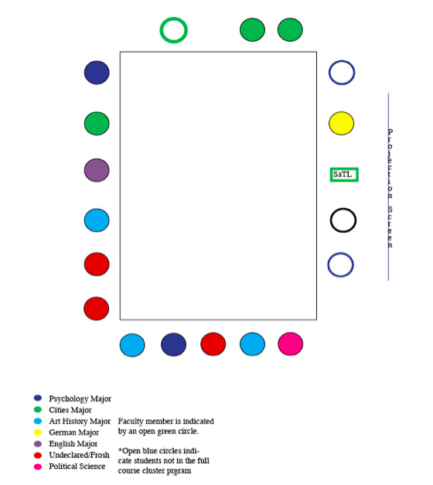

Figure 1: Basic Classroom Map

- From a basic map such as the one above, mark discussion and participation as it happens:
- Draw lines connecting individuals who speak to one another’s contributions
- Mark students who participate verbally with semi-circles radiating from their position on the map, drawing the semi-circles thicker or thinner based on how long a student speaks (e.g., a student who offers a one-word response to a call for input would have her participation marked by a thin semi-circle; a student who speaks for a longer amount of time and makes more connections and analysis in her response might have that participation marked by a thick semi-circle).

This adding in of participants, contributions, and interactions is captured in another map that Sophia created, shown in Figure 2 below.

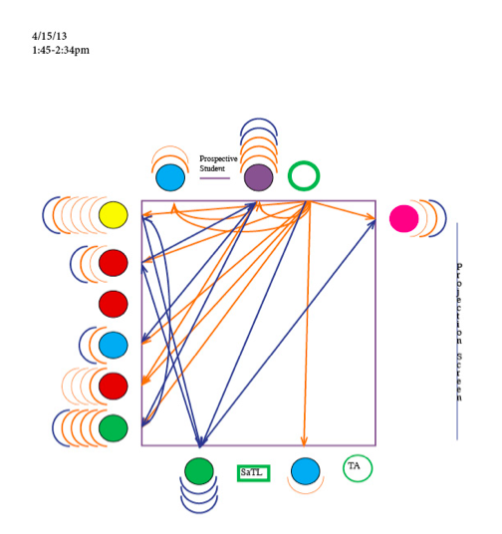

Figure 2: Classroom Map with Participant Contributions

In the map above that Sophia created there are two different discussions—one in orange and one in navy blue—both of which were led by students in addition to the faculty member following student presentations. Almost every student in the class participated vocally in the orange discussion and slightly fewer students spoke in the navy blue discussion. The map notes that these discussions took place between 1:45pm and 2:34pm. Noting the arrows between individuals, one can see who spoke to whom. For example, an arrow leading from the professor to a student indicates the student spoke in response to the professor. In other words, the professor’s comment led to the student’s response.
This kind of information, coupled with notes on what individuals say and how the dynamics of the classroom shift over the course of the session, can help faculty and student partners reflect on what aspects of the faculty member’s pedagogy might have prompted important learning moments; through analyzing the relationship between the plans faculty had for a class session and the maps of that session, these moments can be identified and explored.
Together, the visual maps student consultants create and the written observation notes they generate can provide a sense of engagement and an idea of how comments are being filtered and sometimes recast or redirected by various members of the class. As Sophia argues: “In this way, the maps as visual representation are a metaphor for the classroom itself. Days, weeks, and months after a particular session, I can look back to the maps and see how discussion moved through the room, who took up more or less vocal space, and how students interacted with each other and their professor” (Abbot, Cook-Sather, and Hein 2014).
A faculty member who used classroom maps described in the box below the benefits she experienced:
“My immediate post-lesson review of the maps with my consultant was productive both in making visible these patterns and in helping me think about how to address them. By juxtaposing my lesson plans with her observation notes and participation maps, I had the perfect log to ascertain which aspects of the lesson elicited the desired types of interaction, and from which students, which in turn helped me plan the next lessons. For example, if Jane Doe had five marks of involuntary participation and never directly addressed another student, then I would do my best to craft in-class activities or homework to facilitate her voluntary participation. In so doing, I hoped that she would be compelled to actively participate more often and consequently gain confidence in using the French language to articulate her views.” – Corbin 2014

Why might student and faculty partners want to map small-group discussions?
Often students interact very differently in small groups than they do in a larger group. It is difficult, however, for faculty members to get a sense of what is happening in all small groups while facilitating the progress of the entire class. Student consultants can use mapping to capture those interactions and share them back with their faculty partners.
In one of Sophia’s partnerships, her faculty partner experimented with using small-group work before breaking out into a larger class discussion. The maps offered him a visual representation of the shift in how students participated during and after small group work, as represented in Figure 3 below.

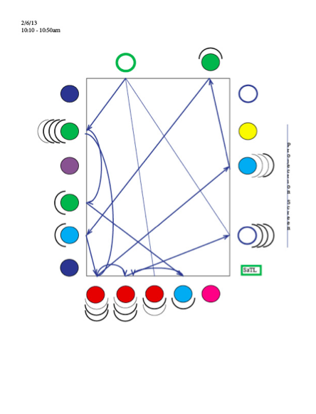 | 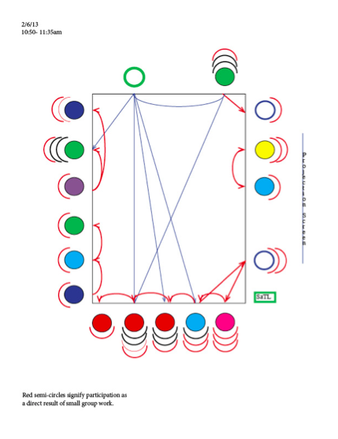

Figure 3: Classroom Interactions Before and After Group Work

For the first half of the class (the map on the left), when the faculty member alternated between lecture and full group discussion, student participation was not evenly distributed. Some students participated much more regularly than others and some did not participate at all. During the second half of the class (the map on the right), during which the professor introduced and facilitated small group work, the levels of participation were more even as seen in the red discussion and participation lines.
Another student partner, Damon Motz-Storey, created a map of a science classroom for a team of his faculty partners. Given a particular interest faculty partners had regarding gender and racial dynamics in science classrooms, Damon plotted students according to these dimensions of identity. In Cook-Sather and Motz-Storey (2016), Damon offered an explanation of the map, which uses lines to represent “collaborations between students during class when the professors intended for students to be working together on course material. If two students have a line connecting each other, it means that at some point, those two students talked to each other to share a question, comment, idea, or insight relevant to class material” (172).

“The faculty members teaching this class used this map to develop classroom practices that brought students claiming different identities into dialogue with one another in order to make connections across lines of difference. As a result, students expressed in class a pleasant surprise at learning more about one another’s experiences, and it felt clear to Motz-Storey that ideas about the content were shared more openly as a result” - Cook-Sather & Motz-Storey 2016, 172

If student partners provide faculty partners with collections of such maps, those can offer a sense of how much grouping is occurring within and across different identities within the classroom. Grouping can mean different things: “While grouping can be a sign of exclusion linked to underperformance, it can also be a sign of solidarity among those traditionally underserved” (Cook-Sather and Motz-Storey 2016, 173). If faculty and student partners want to identify and analyze particular patterns of engagement and interaction, student consultants can track interactions among students of different age groups, students majoring in different subjects, or students with pre-existing social connections (e.g., members of athletic teams). As Cook-Sather and Motz-Storey (2016, 173) caution, “Regardless of the dimensions of identity used as referents, however, faculty members and student consultants should not jump to conclusions about patterns that they see, but multiple representations might throw into relief recurring and problematic dynamics, as well as beneficial ones.”

“… having the maps as a point of reference made it easier for me to facilitate the class and assess student performance because I was not forced to do both concurrently. Over time, I could trace patterns in students’ engagement, note who commonly responded to whom, and even anticipate the types of in-class work that would best engage this group.” – Corbin, 2014

Corbin’s emphasis above on analyzing and re-analyzing, on tracing, responding, anticipating, planning, and revising, highlight the importance of using maps as heuristics, not as static representations with transparent meaning. We highlight in a final section of mapping the importance of this point and offer other cautions of using maps by summarizing points that Sophia made in her explanation of mapping (Abbot, Cook-Sather, and Hein 2014).

What should student and faculty partners be cautious about in mapping?
Like other forms of observation and analysis in which student partners engage, classroom mapping requires student partners to develop new modes of attention, new capacities, and a new sense of responsibility. We enumerate those here.

Student partners need to draw upon a different skill set and a different perspective
One of the challenges of creating maps is that it requires a different mindset and a different approach from what most students as accustomed to. Sophia emphasized that, “In creating the maps, it was important that my role was one of a third-party observer in the classroom”—not first-party participant. She continued: “Keeping the notes necessary to develop these maps meant making intensive observations that I would not have been able to maintain as a student enrolled in the class and that a faculty member could not produce while teaching the class.” This skill, Sophia suggests, is not developed instantly: “In fact, other student consultants reported—and I found myself—that it took a few practice rounds mapping before we were comfortable both mapping the classroom and taking supplementary notes” (Abbot, Cook-Sather, and Hein, 2014).

“The skills and focus of the creator of classroom maps are not the same as those of a student enrolled in the course.” – Abbot, Cook-Sather, and Hein 2014

Maps are for exploration and learning, not evaluation and judgment
As Alison has argued:
…it is critical not to assume that there are correlations between pedagogical practices and student participation or that participation equates with engagement or learning. Maps can throw into relief the multiple variables that affect student contributions, but deeper and ongoing analysis is necessary to unpack the complicated relationships among participation, engagement, and learning” (Abbot, Cook-Sather, and Hein 2014).
Sophia made a related argument from her perspective as a student partner:
From my perspective, these maps are not meant to act as evaluative tools within classrooms. Instead, the information the maps offer may be used to consider and learn more about the effects of different pedagogical techniques on the part of the faculty member. Rather than judge a student who does not speak, faculty and their consultants can ponder what kinds of questions, activities, and facilitation encourage or hinder which kinds of participation. (Abbot, Cook-Sather, and Hein 2014).

It is essential to maintain anonymity
Mapping what students do and say can become invasive and problematic if their names and identities are public. As Sophia explains: “It is important to maintain anonymity of the students and faculty members in creating these maps (especially if the maps are going to be shared). This is because visually showing the way individuals interact can be vulnerable-making for those involved” (Abbot, Cook-Sather, and Hein 2014). If student and faculty partners plan to use mapping, they need to be sure that they are thoughtful about how they go about it: “It is important to be intentional about using maps in ways that do not make students or faculty overly self conscious or anxious.” As Cook-Sather and Motz-Storey (2016) also argue, faculty and student partners should avoid making assumptions and overgeneralizing from the maps. And as Sophia contends: “Everyone involved should understand the maps as heuristics for exploring and enhancing faculty facilitation and student participation” (Abbot, Cook-Sather, and Hein 2014).

“The maps heighten faculty members’ meta-cognitive awareness, but they may also be used as a tool to introduce and discuss meta-cognitive awareness amongst students: they could be shared with students to let them see how much and how little they and their classmates are participating. Here again, maintaining the anonymity of students is crucial, and not judging but rather analyzing for the purpose of understanding are key.” – Abbot, Cook-Sather, and Hein 2014

Where can student and faculty partners learn more about mapping classroom dynamics and participation?

Abbot, Sophia, Alison Cook-Sather, and Carola Hein. 2014. “Mapping Classroom Interactions: A Spatial Approach to Analyzing Patterns of Student Participation.” To Improve the Academy: A Journal of Educational Development 33(2), 131–52. https://doi.org/10.1002/tia2.20014

Cook-Sather, Alison, and Damon Motz-Storey. 2016. “Viewing Teaching and Learning from a New Angle: Student Consultants’ Perspectives on Classroom Practice. College Teaching 64(4), 168–177.

Corbin, Kathryn A. 2014. “Get out the Map: The Use of Participation Mapping in Planning and Assessment.” Teaching and Learning Together in Higher Education 11. https://repository.brynmawr.edu/tlthe/vol1/iss11/8

