A Day in the Life of Gavia stellate, a Red-Throated Loon

Today we are reporting on a very interesting species of bird known as the “Red-throated loon”, whose scientific name is Gavia stellate.

Different Appearances of the Red-Throated Loon
One of the most distinguishing characteristics of a red-throated loon is its bright red throat. However, its red throat is only seen during its breeding season. During breeding season, the summer, the loon has a dark brown or black body with a white breast and a red throat. Additionally, it has red eyes and a thin, black beak that is usually tilted upward.
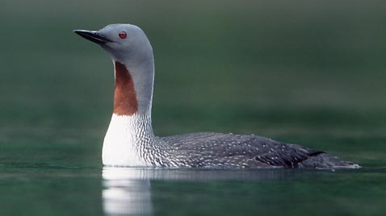

During all other times of the year, however, the loon has a difference in appearance. During non-mating season, it loses the intense red coloration and is pale gray and white, with a white breast and gray and white head.
Pictures and information from http://www.allaboutbirds.org/guide/Red-throated_Loon/id

Breeding Behavior of the Red-Throated Loon

Because of their leg structure, it is hard for red-throated loons to walk on land and therefore, these loons only go on land to nest. When these loons create on-land nests, they are located near low shorelines and are made up of grass and moss. Meanwhile, some loons remain in the water to nest and create their nests in shallow waters and make them with substances and vegetation that they find in their aquatic environment. The average clutch size for a red-throated loon is about 1-3 eggs and the eggs appearance is an olive or brown coloration with speckles.
Red-throated loons are monogamous and both parents are responsible for caring for the offspring. Both the male and the female build the nest and care for and incubate the eggs. The care from the parents also continues after the eggs hatch. One day after hatching, the newborn loons leave the nest to avoid predators but return shortly after and are again cared for by their parents.
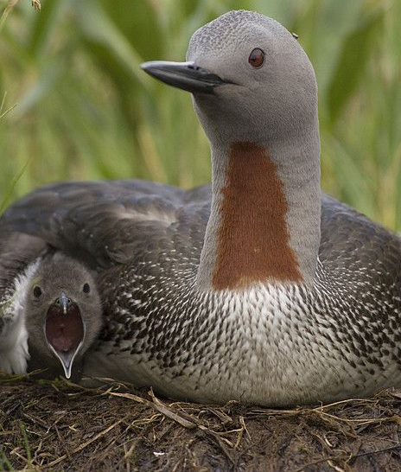
Photo: http://media-cache-ec0.pinimg.com/736x/a5/a7/2a/a5a72a108e58507057f544d43a58bfbb.jpg

Information from:
http://birdweb.org/birdweb/bird/red-throated_loon
http://www.allaboutbirds.org/guide/Red-throated_Loon/lifehistory

The Red-Throated Loon’s Habitat and Foraging

Like many other species, the red-throated loon migrated during the winter and therefore, based on the season they can be found at different locations. During breeding season, the summer, these loons reside in low wetlands, ponds, and swamps. Typically, as seen on the map, during this time, they resided in northern Canada, which is depicted in orange on this map. During non-breeding season, the red-throated loons are found in more southern Canada and to parts of the United States. During the non-breeding season would be when we would be able to see these Red-Throated Loons in Duchess County, New York. During non-breeding season, they typically live in shallow sheltered marine habitats or the ocean. Lastly, during migrating season, red-throated loons live in large lakes or oceans.

Food
Because these loons very frequently leave marine habitats, they scavenge the water for food. Due to its body shape, the red-throated loon can dive very far below the surface. The diet of a this bird consists of fish, crustaceans, mollusks, and other marine life
Information and Picture from: http://www.allaboutbirds.org/guide/Red-throated_Loon/lifehistory
Social Behavior of the Red-Throated Loon
Typically, the red-throated loon lays low in water due its dense bones. From this position, the loon can either dive for food or take off to flight. The red-throated loon is the only type of loon that can take off directly from its sitting positioning and does not need to have a running start. Due to the loon’s tendency to dive for food, it is very important for the loons to protect their feathers. On a daily basis, these birds preen to help keep their feathers waterproof.

In addition to these behaviors, the red-throated loon has a few other tendencies that vary based on the season. Loons typically reside in water but during breeding season, loons wander away from their nesting pond and nest on land. On the other hand, during the winter, red-throated loons feed in small groups and congregate.
Picture: http://upload.wikimedia.org/wikipedia/commons/0/0f/Red-Throated_Loon_Iceland.jpg
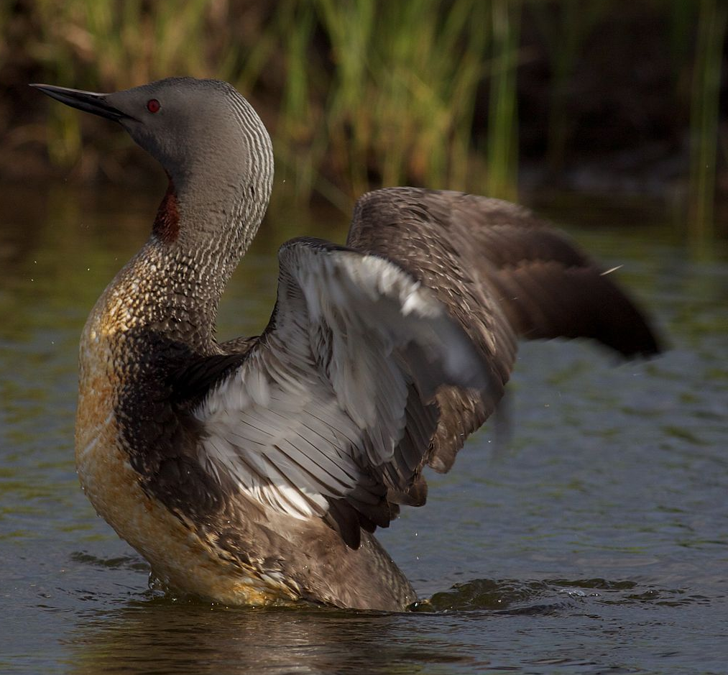
Information from http://birds.audubon.org/birds/red-throated-loon

