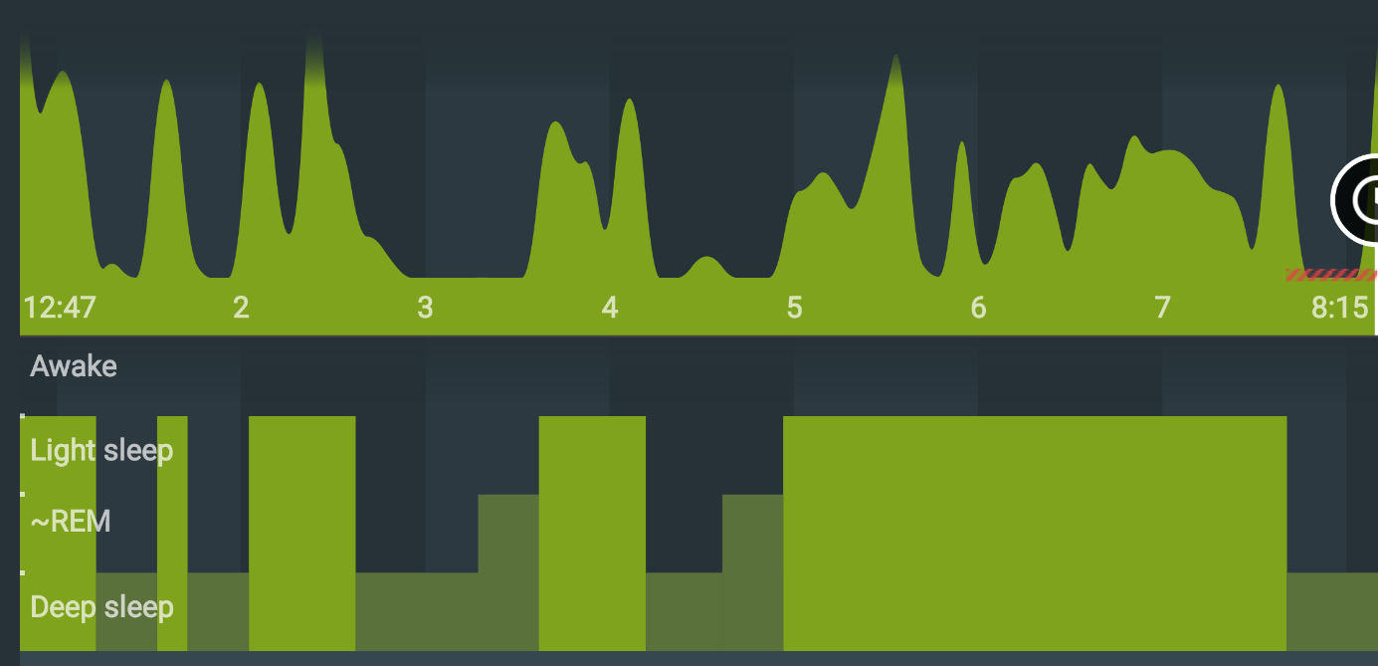

**Day 1, Sleep as Android**

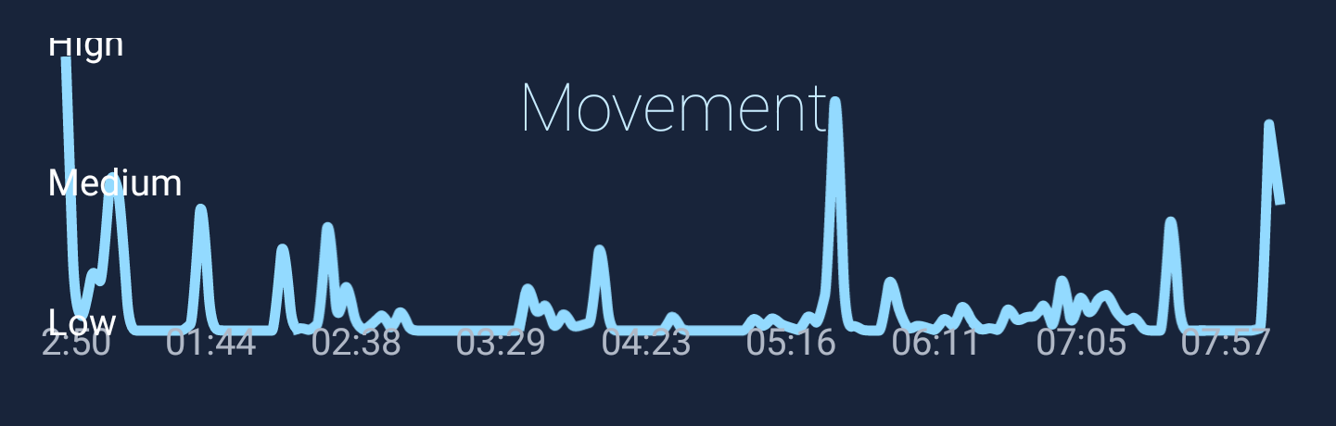

**Day 1, SleepBot**

**\***Probe came off at some point

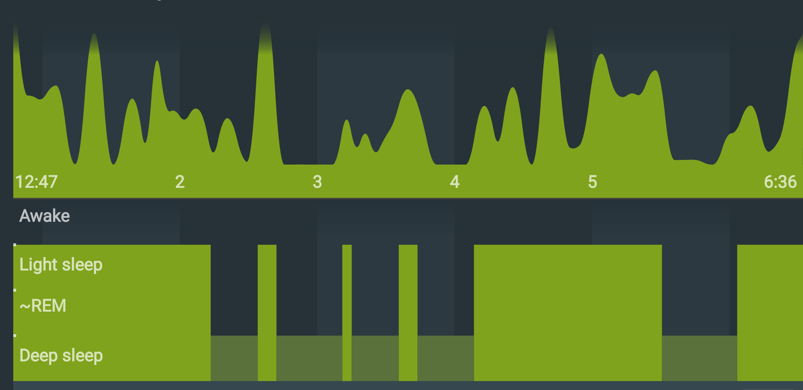

**Day 2, Sleep as Android**

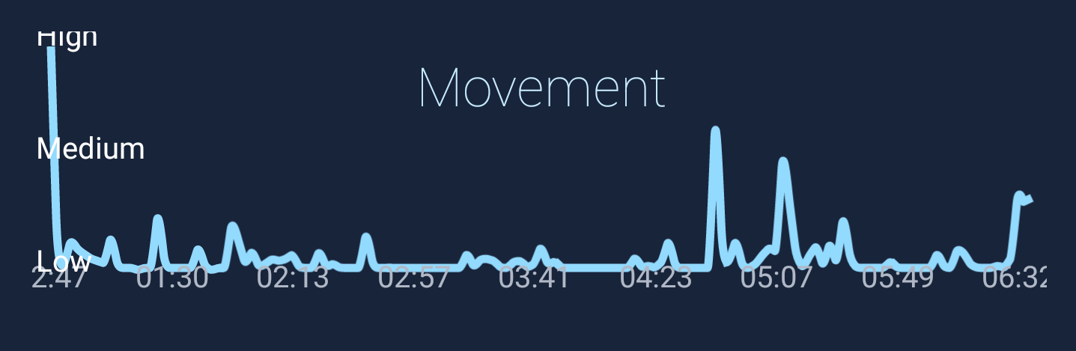

**Day 2, SleepBot**

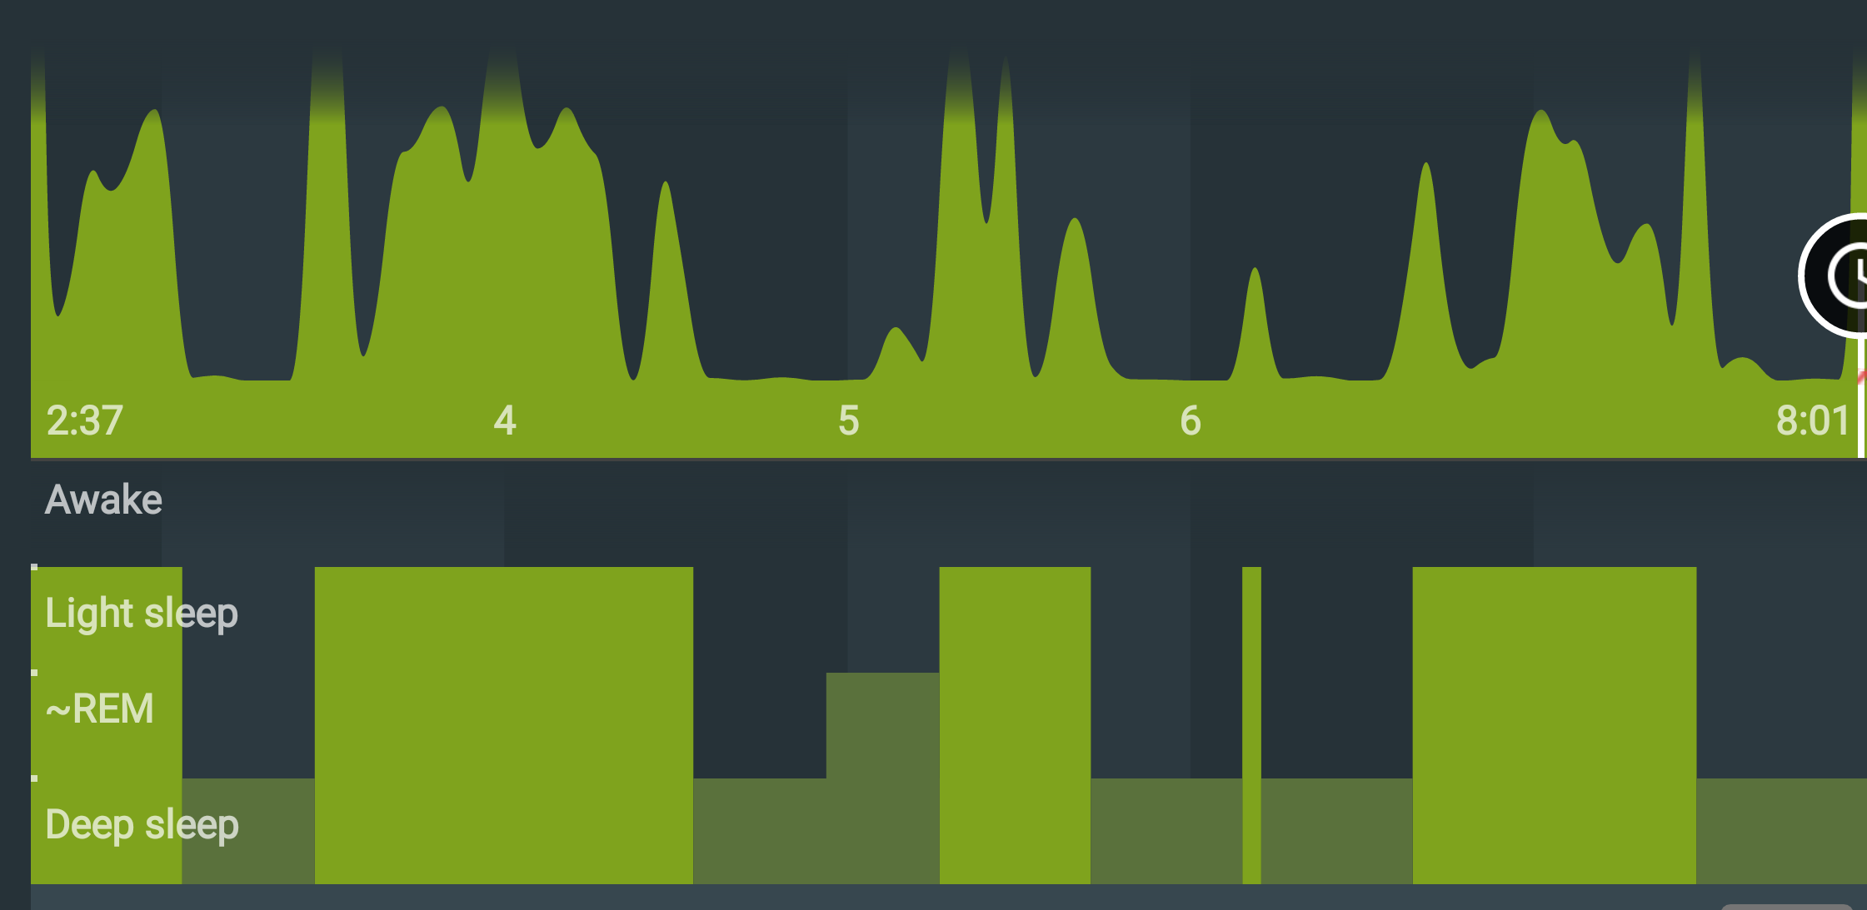

**Day 3, Sleep as Android**

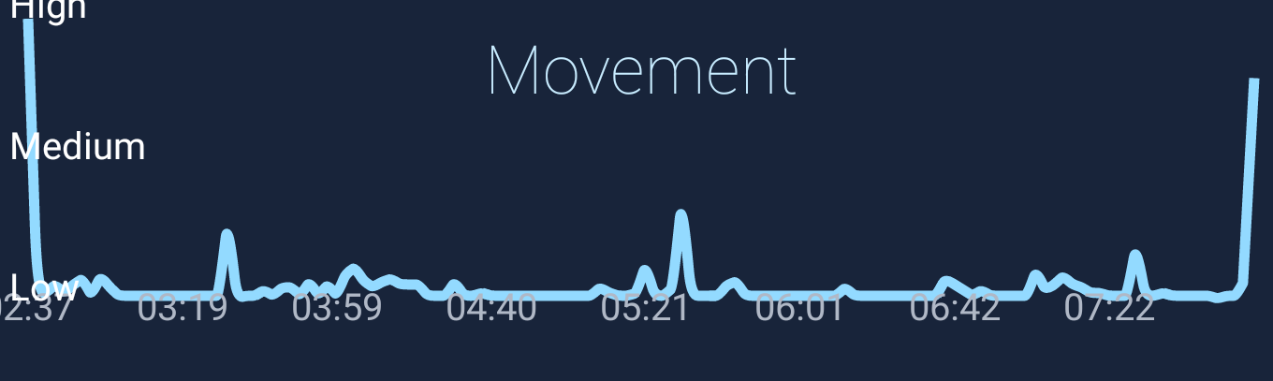

**Day 3, SleepBot**

**Day4**

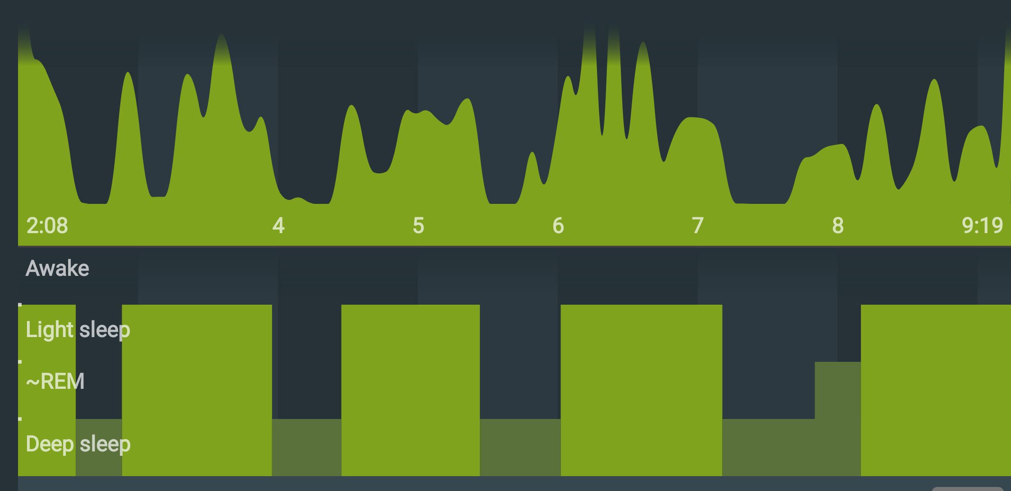

**Day 4, Sleep as Android**

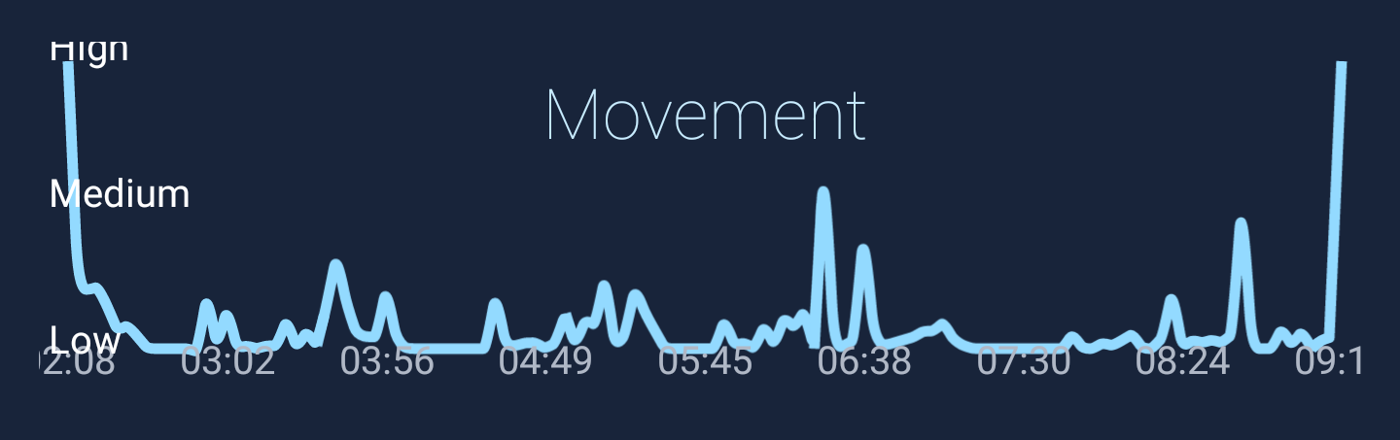

**Day 4, SleepBot**

**Day5**

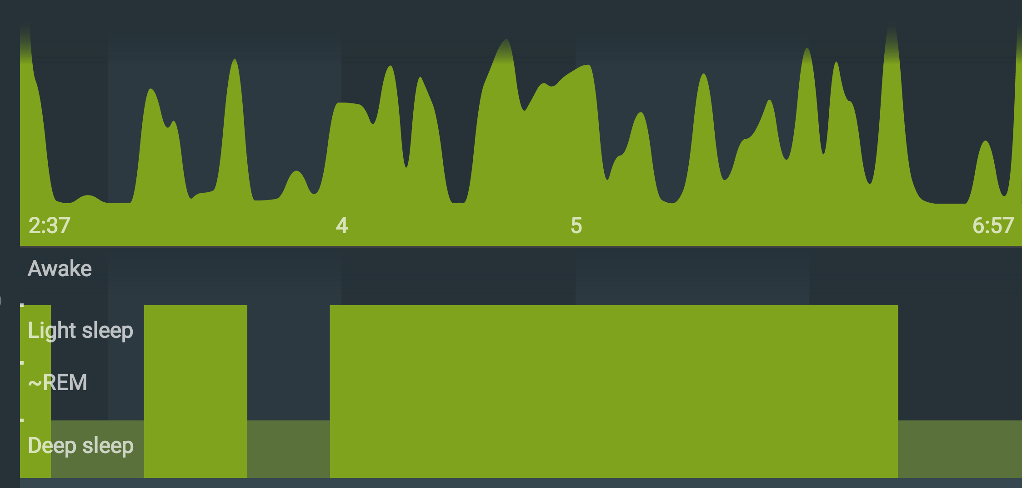

**Day 5, Sleep as Android**

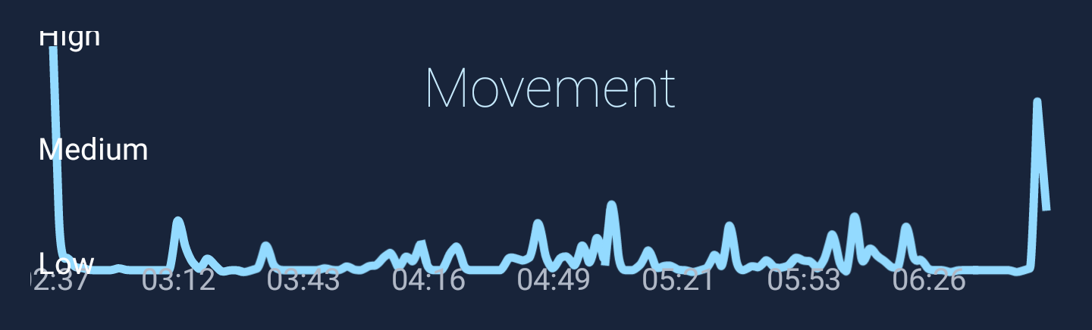

**Day 5, SleepBot**